**Pokemon Eternal Snow V2.0**





**Name: Pokemon Eternal Snow**

**Language: English**

**Rom Base: Pokemon Emerald 650 Patch from LCCoolJ95**

**Story: Three rounds**

**Difficulty: Hard**

**Terrace: GBA**

**Total numbers of Pokemons: 672**

**Main creditor: Reshiram white as snow (大型宽体飞机 in tieba)**

**Version: 2.0**

**Complete Date: April 1, 2016**

**Logo introduction**

**This is a not profit Pokemon hacked game. I have started this in the last year, it spent me more than 4 months to make. Some people will ask me how did I make these such as Pokedex expansion, new evolution method and etc when they are playing my game. I have to tell you, these are not made by myself, it is come from LCCoolJ95’s 650 Patch, I wrote the story in this game only. He has spent about 7 years to make this Rom Base, so I think I need to give him credit, that this game is not only belong to mine but also belong to LCCoolJ95. I will ask everybody please regard my game, thanks a lot:**

1. **If you want to play my game, lease play my game completely, and please do not use the cheating code. Because I have spent too much time on make this game, and LCCoolJ95 has spent several years on make and improve the Rom base.**
2. **Please do not use Pokemon Eternal Snow V2.0 to be your Rom base randomly, and please do not use any materials from Pokemon Eternal Snow V2.0 to your Pokemon game randomly.**
3. **Please patch the Pokemon Eternal Snow V2.0 on Emerald pure version (US), do not patch it on someone hacked game without the permission from the creditor. If you patch it on a hacked game or other language of the Emerald, it may be happen the data conflict, and the game cannot be played.**

**Game introduction**

**This game has 18 different types of Gym and 3 Leagues. At the beginning, you will see a special area**

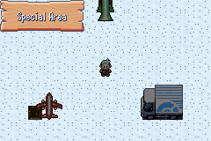

**The first League is the same as Emerald; the second league is N league, he will use five kind of weather team, they are sandstorm, sunny, rainy, snowy and regular team.** 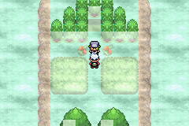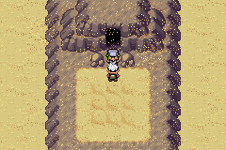

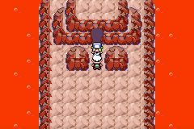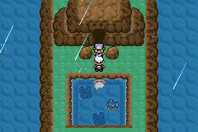

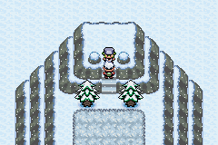

**The third League is a five continuous battle, you cannot relax until you win or loss in this whole battle**

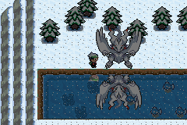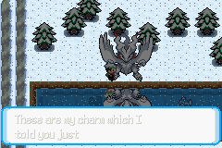

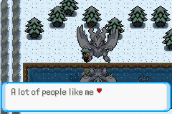

**In this game, you can get Eevee at the beginning only, and Eevee can evolve into different forms when you level up on different planets. You can get two Pokeballs before you catch it, these two balls are hidden at the beginning of city.**

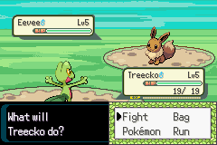

**Bug notes:**

1. **When the Castform change the form, it will change into black color, please ignore it.**
2. **When you go to Pokemon Contest, the game will be crashed, so I have hidden this story. It will not supply until this bug has been fixed.**
3. **I have added 23 more Pokemon in 25 empty places, but I have not write the summary of these Pokemon, because I am lazy. Although I write down these, I guess there are a few people will look it only.**
4. **Please do not move the Pokedex to higher than 650, the game will be crashed when you move the Pokedex to the bottom. I still haven’t figure out how to fix this bug, if you know how to fix it, please let me know, thank you very much.**
5. **Please Catch all of the round 1 Legendary before start the round 2 story, and catch all of the round 2 Legendary before start the round 3 story. Because if you are not according to this, it may happen some of legendary disappeared.**

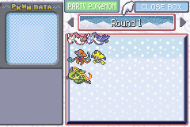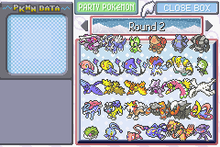

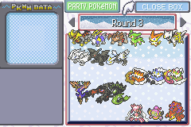

1. **English is not my first language, so it may exist a lot of grammar error, if it has, please let me know, thanks.**
2. **If have more bugs, please let me know, I will try my best to fix it, thank you. If this game has against the rules, please tell me immediately, I will remove it at once when I saw it. Please do not argue or use bad sentences to attack me for that.**

**In additionally, I have to recognize this Pokemon game is similar as Pokemon Ebony Phantom 5.0EX The Boundless Chaos, some people know that game is the best Emerald hacked game in China, because the story is very long and interesting, it has added more than 100 Gen4-5 moves, a lot of Gen4-5 items and abilities.**

**You can found there are a lot of things can be renewed if you are playing my game very seriously. Such as catch the legendary randomly, I haven’t set any of condition to catch them. For example, you cannot catch the Zekrom and Reshiram until you have got the Light Stone and Dark Stone; you cannot catch the Heatran until you have got the Magma Stone. I haven’t set these yet, it just you can catch any of legendary when you have found them. Also, each of planets can be expanded bigger, such as the area, the story and etc. There are a few of Gen 6 Pokemons has been added only, so you can found the Pokedex can be expanded more. But I don’t have enough time to renew it now, although I am 23 years old, I still haven’t girlfriend yet, and I need to take the GRE test for master. So I cannot do the large renew at least right now. If someone wants to be my successor, I will be glad in any of time, please tell me. Thanks a lot!**

**This is the adage of this Pokemon game:**

**Snow will be melt eventually, but it’s bright and white will be eternal.**